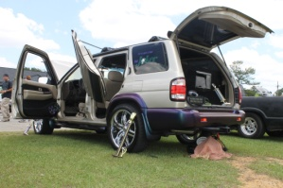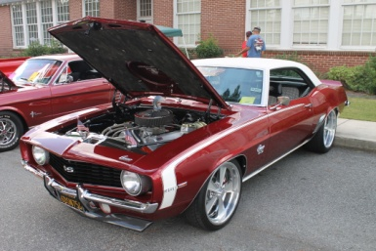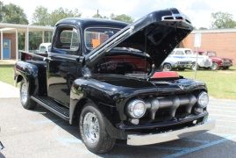
Shade Tree Rod & Custom
Car Club & Sumner Egg Festival Presents
9th Annual Street Dance & Car Show
Friday, September 20, 2013 & Saturday, September 21, 2013

Friday Night Street Dance 7 p.m. to 10 p.m. Live DJ
Cash Prizes Awarded in the Slowest Tractor Race & Fastest Lawn Mower Race
ALL PROCEEDS BENEFIT THE AMERICAN CANCER SOCIETY
Pre-Entry Registration Fee: $15 After September 1, 2013: $20
Registration Time: 8 a.m. to 11 a.m. Judging: 12 p.m. to 2 p.m.
Awards & Door Prizes: 3 p.m.

Awards: Top 15, Hard Luck, Best of Show, & Long Distance

Games: Sock Pull, Piston Toss, Fan Belt Toss, Spark Plug Change, &
Valve Cover Race.
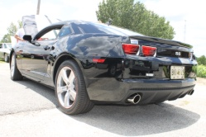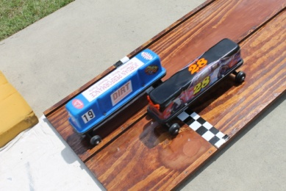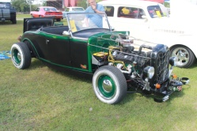
Shade Tree Rod & Custom Car Club and Sumner Egg Festival are not responsible for injuries, loses, or damages to person or property or judgments or claims from any cause whatsoever that may be suffered.

Signature of Applicant: _______________________________
Name: _____________________________________________
Address:____________________________________________
City: _______________ State: _________ Zip: ____________
Car Make: _______________Model: ________ Year: ______

ALL PROCEEDS BENEFIT THE AMERCIAN CANCER SOCIETY
Mail Registration to:
Shade Tree Rod & Custom Car Club
Attn: Delores Burger
P O Box 847
Sumner, GA 31789

For more information please call
Christie Burger at 229-206-4015
or Delores Burger at 229-776-5823

